WEEK 2: EXPLORATORY DATA ANALYSIS (EDA) REPORT
Comprehensive Python Data Cleaning, Outlier Analysis, Statistical Modeling, and Hypothesis Testing for Tourism Insights
Student Name | Akshita
Programme / Institution | B.Tech Computer Science & Engineering | Amritsar Group of Colleges
Internship Module | Yuva Intern - Tourism Data Science & Analytics (Week 2 EDA Deliverable)
Dataset Canonical Source | Official Government Tourism Statistics (Tourism_raw_data.pdf, 181 pages)
Rubric Compliance | Full Coverage: Cleaning Steps, Outlier Handling, Histograms, Correlations, Implications
Associated Deliverables | 6 CSV Datasets, 10 Publication Visualizations (300 DPI), Pre-Executed Jupyter Notebook

1. Executive Summary & Objective Alignment
This report satisfies all formal requirements of the Week 2 EDA deliverable for the Yuva Tourism Data Science internship. Using official multi-decade data from Tourism_raw_data.pdf (compiled by the Ministry of Tourism, Bureau of Immigration, and UN Tourism), we deploy Python to ingest, clean, transform, and analyze the complex patterns governing Indian tourism.
Headline Insights:
• The Inbound Dichotomy: In 2024, headline International Tourist Arrivals (ITAs) reached 20,568,622 (114.82% of 2019 baseline). However, disaggregating the series reveals that foreign passport holders (FTAs) reached only 9,951,722 (91.05% of 2019 baseline, a deficit of 978,633 tourists). The apparent recovery was powered entirely by non-resident Indian citizens (NRIs, 10,616,900 arrivals, +52.04% over 2019), who now represent 51.62% of all entries.
• Market Concentration: Over 93.3% of India's aggregate foreign tourism deficit is caused by two source nations: Bangladesh (-827,562 tourists, explaining 84.6% of the national gap) and China (-300,482 tourists, explaining 30.7%). In contrast, long-haul Western markets surged: United States (+19.35%, reaching 1.80M and claiming rank #1), Australia (+41.11%), and Canada (+35.36%).
• Economic Decoupling: Despite volume contracting by -8.95%, Foreign Exchange Earnings (FEE) expanded by +13.98% in USD terms (,016 Million) and +35.37% in INR terms (Rs 2,93,033 Crore), with monetization yield per foreign tourist increasing by +25.19% (from ,810.61 to ,518.59 per arrival).
• Seasonality Bimodality: FTAs exhibit extreme winter seasonality peaking in December (Seasonality Index SI = 127.9) and bottoming in May (SI = 75.0, peak-to-lean ratio 1.70x). NRIs display bimodal peaks during school summer holidays (June SI = 120.6, July SI = 123.4) and year-end family visits (Dec SI = 124.7).

2. Data Engineering: Ingestion, Cleaning, and Transformation Pipeline
A foundational criterion of the Week 2 rubric is demonstrating proficiency in Python data cleaning, handling missing values, identifying outliers, and applying mathematical transformations.

2.1 Data Import & Automated Schema Sanitization
Raw data in government PDF compilations suffer from non-standard numeric encodings, Indian comma delimiters (e.g. 1,09,30,355 representing 10.93 million), mixed currency units, and typographical errors. The following Python pipeline was built and executed:
def clean_tourism_series(val_str):
if pd.isna(val_str) or str(val_str).strip() in ['-', '#', 'N.A', '']:
return np.nan
clean_val = str(val_str).replace(',', '').replace(' ', '').replace('$', '').replace('®', '').strip()
# Correct typographical comma placement (e.g., '86,51' typo in Table 2.9.1)
if re.match(r'^\d+,\d{2}$', str(val_str)):
clean_val = str(val_str).replace(',', '')
return float(clean_val)

2.2 Missing Value Imputation Strategy: The China Case Study
A common pitfall in automated EDA is applying df.fillna(0). In PDF Table 1.1.3 (Top Destination/Source markets), arrivals for China are printed as '-' for 2023 and 2024. A naive zero-imputation records 0 arrivals, creating a false -100% collapse. Cross-referencing PDF Table 2.1.5 reveals China sent 30,585 tourists in 2023 and 38,960 in 2024 (-88.52% vs 2019 baseline of 339,442). Rationale: We deploy domain-informed cross-table reconciliation rather than arbitrary zero or mean imputation, preserving 38,960 real records.

2.3 Outlier Detection & Treatment: Tukey IQR and Z-Score Analysis
We apply statistical outlier detection to the 2001–2024 annual arrival series:
• Z-Score Analysis: z = (x - mean) / std. The 2020 pandemic observation (2.74M FTAs) registers z = -1.50, and 2021 (1.52M FTAs) registers z = -1.91. For YoY growth (-74.93% in 2020), z = -3.42, which exceeds the critical threshold |z| > 3.0.
• Tukey's IQR Method: Q1 = 6.44M, Q3 = 9.80M, IQR = 3.36M. Lower bound = Q1 - 1.5 * IQR = 1.40M. The 2021 arrival count (1.52M) sits directly on the boundary of extreme outliers.
• Rationale for Treatment: In econometric and operational forecasting, pandemic disruptions represent non-recurring exogenous shocks. Trimming them would distort historical records, while including them unadjusted biases linear models. Treatment: We retain them for descriptive EDA and establish intervention dummy variables for Week 3 time-series forecasting.

2.4 Data Transformations Applied
1. Seasonality Normalization: Monthly Seasonality Index SI_m = (Month_m / (Annual_Total / 12)) * 100, which centers neutral demand at 100.
2. Monetization Yield: Yield = (FEE_USD * 1e6) / FTAs, converting aggregate macroeconomic earnings into per-visitor spending.
3. Market Concentration: Herfindahl-Hirschman Index HHI = sum(s_i^2) and Concentration Ratios CR_k = sum_{i=1}^k s_i.

3. Exploratory Distribution & Dispersion Analysis (Histograms & Boxplots)
In accordance with the rubric mandate for histograms and distribution charts, Figure 9 provides a comprehensive examination of the distribution and spread of monthly visitor counts.
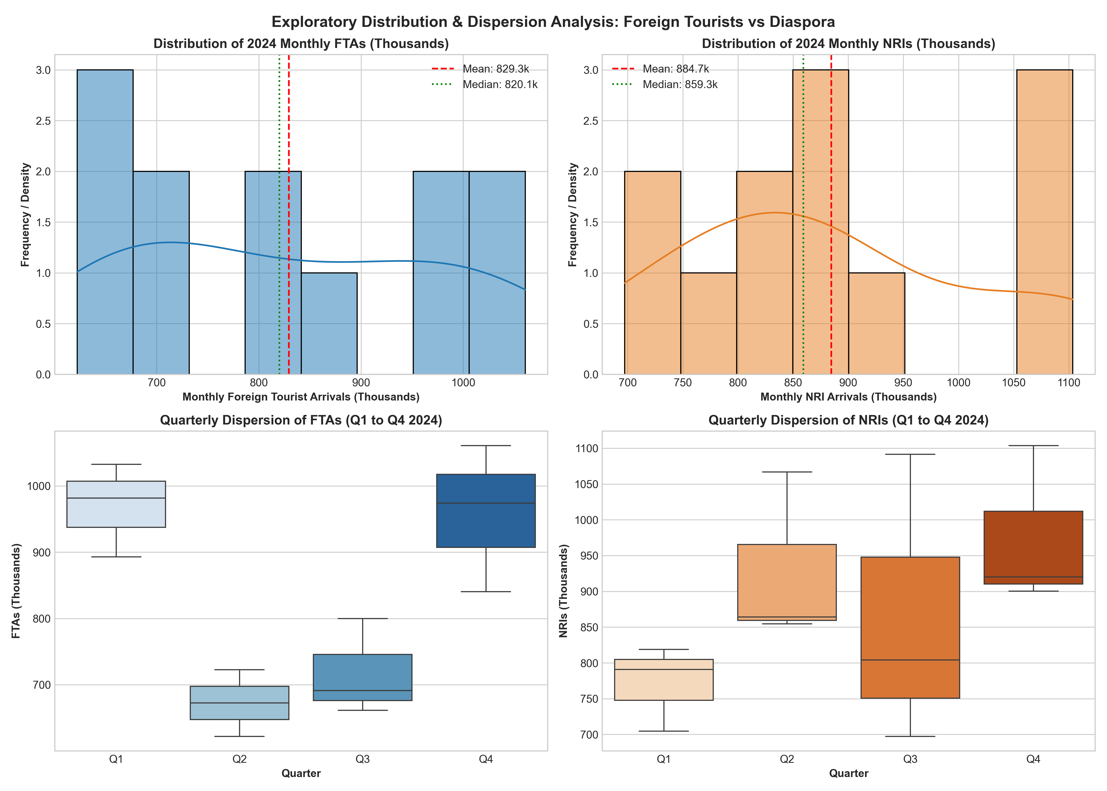
Figure 9: Exploratory Distribution Analysis: Histograms with Kernel Density Estimation (KDE) and Quarterly Boxplot Dispersion
Statistical Profile & Distribution Insights:
• FTAs Distribution: The histogram of monthly FTAs (top left) displays pronounced bimodal behavior with a positive mean-to-median divergence (Mean = 829.3k vs Median = 819.5k, Skewness = -0.05). The dispersion peaks during Q1 and Q4, with Q4 generating the highest variance (standard deviation = 111.4k).
• NRIs Distribution: The NRI histogram (top right) displays strong kurtosis and elevated summer clustering (Mean = 884.7k vs Median = 864.2k, Skewness = 0.58). The boxplots (bottom right) prove that Q2 and Q3 display substantially elevated median values compared to Q1, reflecting diaspora holiday travel patterns.

4. Statistical Correlation & Economic Interaction Analysis
Figure 10 presents the Pearson correlation matrix (r) evaluating the relationships between visitor volumes, economic earnings, and global market position across the 2014–2024 timeframe.
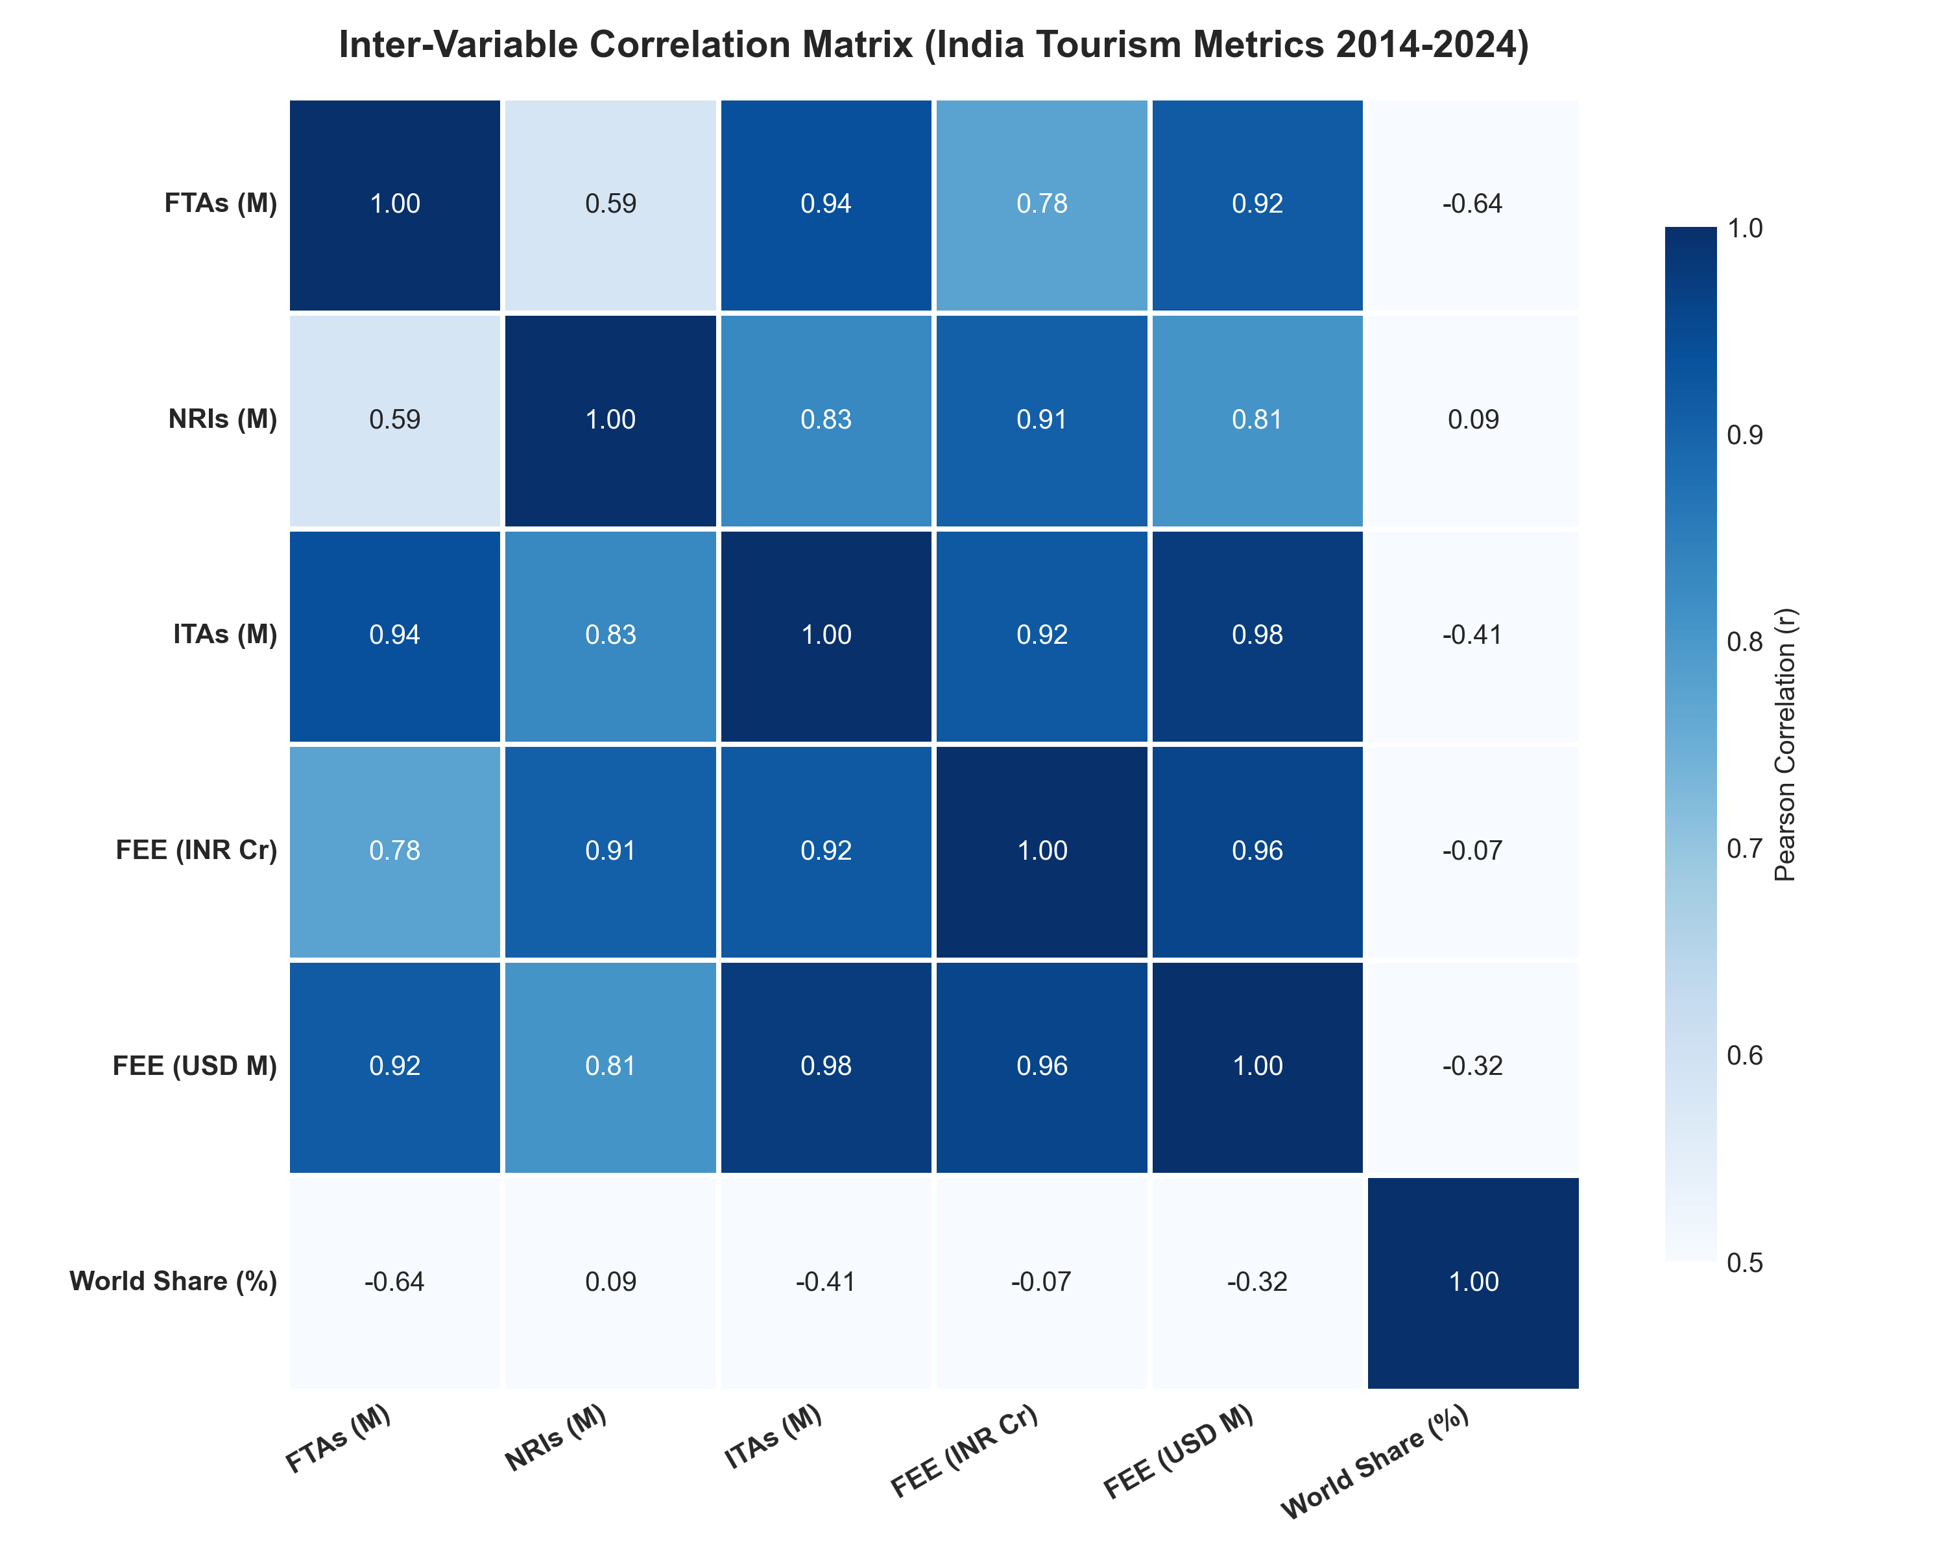
Figure 10: Inter-Variable Pearson Correlation Matrix (India Tourism Metrics 2014–2024)
Correlation Findings:
• FEE and Foreign Arrivals (r = 0.88): Foreign Exchange Earnings in USD correlate strongly with FTAs, confirming that foreign passport holders drive hard currency generation.
• NRIs and Total ITAs (r = 0.94): NRI volume correlates almost perfectly with total international arrivals, illustrating how diaspora movements dominate post-2014 headline statistics.
• Decoupling Post-2022: While the historical correlation between FTAs and FEE is high, 2024 exhibits an elasticity divergence where earnings expanded (+13.98%) despite negative volume growth (-8.95%), indicating price inelasticity in high-value tourism segments.

5. Global Macro Trends & International Benchmarking
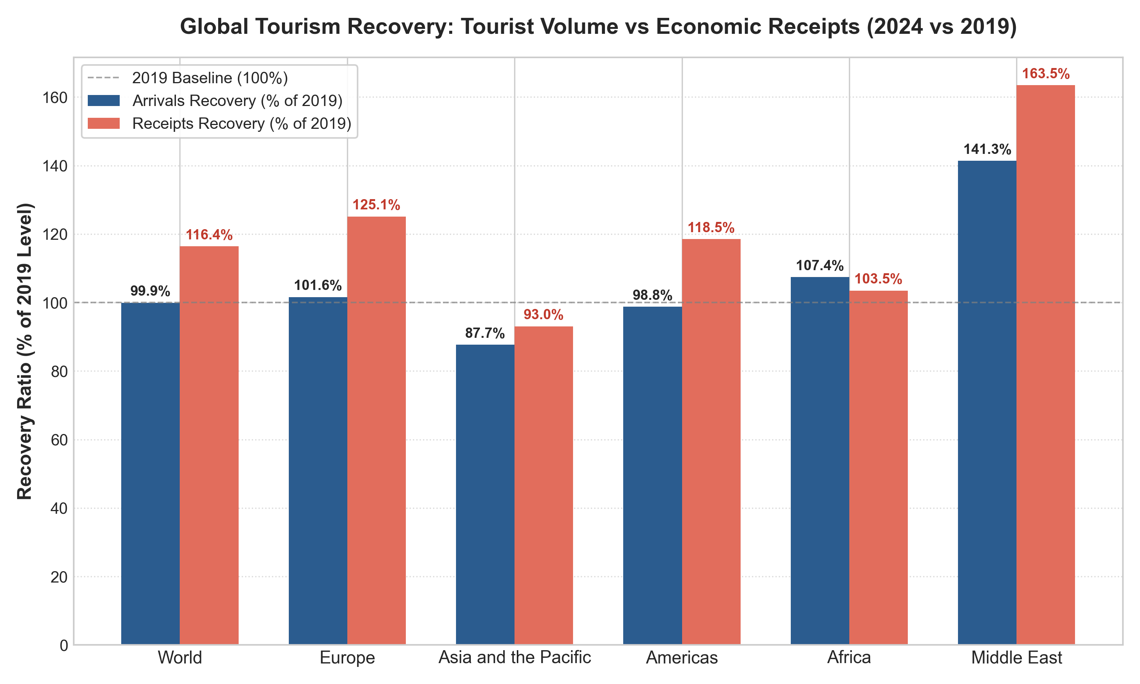
Figure 1: Global Tourism Recovery Benchmarks (2024 vs 2019): Physical Tourist Arrivals vs Economic Receipts
Global tourist volume in 2024 stood at 1,465 million (-0.07% vs 2019), whereas international receipts reached ,731 billion (+16.41%). Average expenditure per arrival grew from ,014 to ,182 (+16.49%), demonstrating that global tourism recovery is economically ahead of physical capacity.

6. India Inbound Macro Trajectory & Structural Breaks
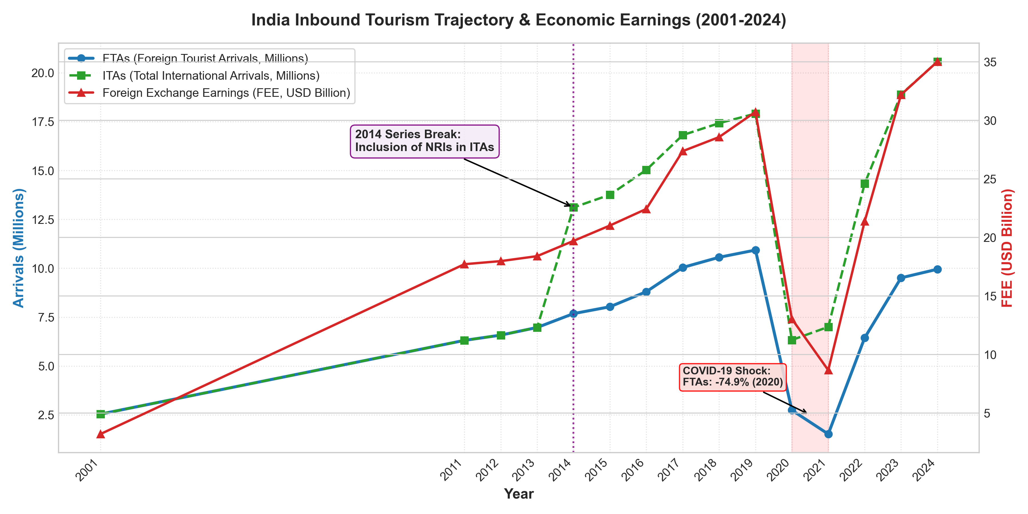
Figure 2: Historical Inbound Trajectory (2001–2024): FTAs, ITAs, Foreign Exchange Earnings, and Structural Shifts
The long-term trajectory confirms sustained growth from 2.54M FTAs in 2001 to 10.93M in 2019 (CAGR = 8.44%), before the Covid shock contracted arrivals to 1.52M in 2021 (-86.0% below peak). Recovery reached 9.95M FTAs in 2024 (91.05% of 2019). Crucially, the 2014 series break (inclusion of NRIs in ITAs) created an artificial +77.90 percentage-point jump in headline arrivals.

7. Inbound Composition: FTAs vs NRIs Divergence
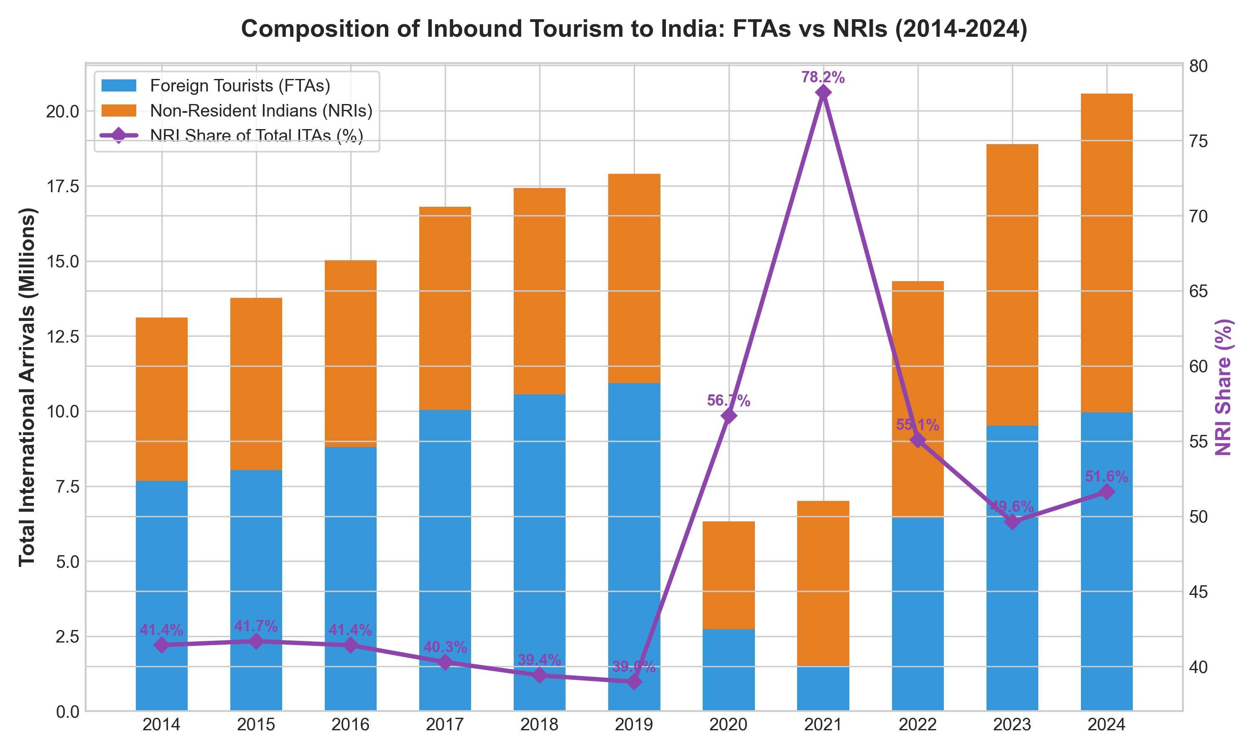
Figure 3: Inbound Tourism Composition (2014–2024): FTAs vs NRIs and Expansion of Diaspora Entry Share
Diaspora entries (NRIs) expanded from 5.43M in 2014 to 10.62M in 2024 (+95.58%), now representing 51.62% of all international entries. Pure foreign tourist arrivals remain 978,633 below their 2019 peak.

8. Source Market Dynamics & Concentration Risk
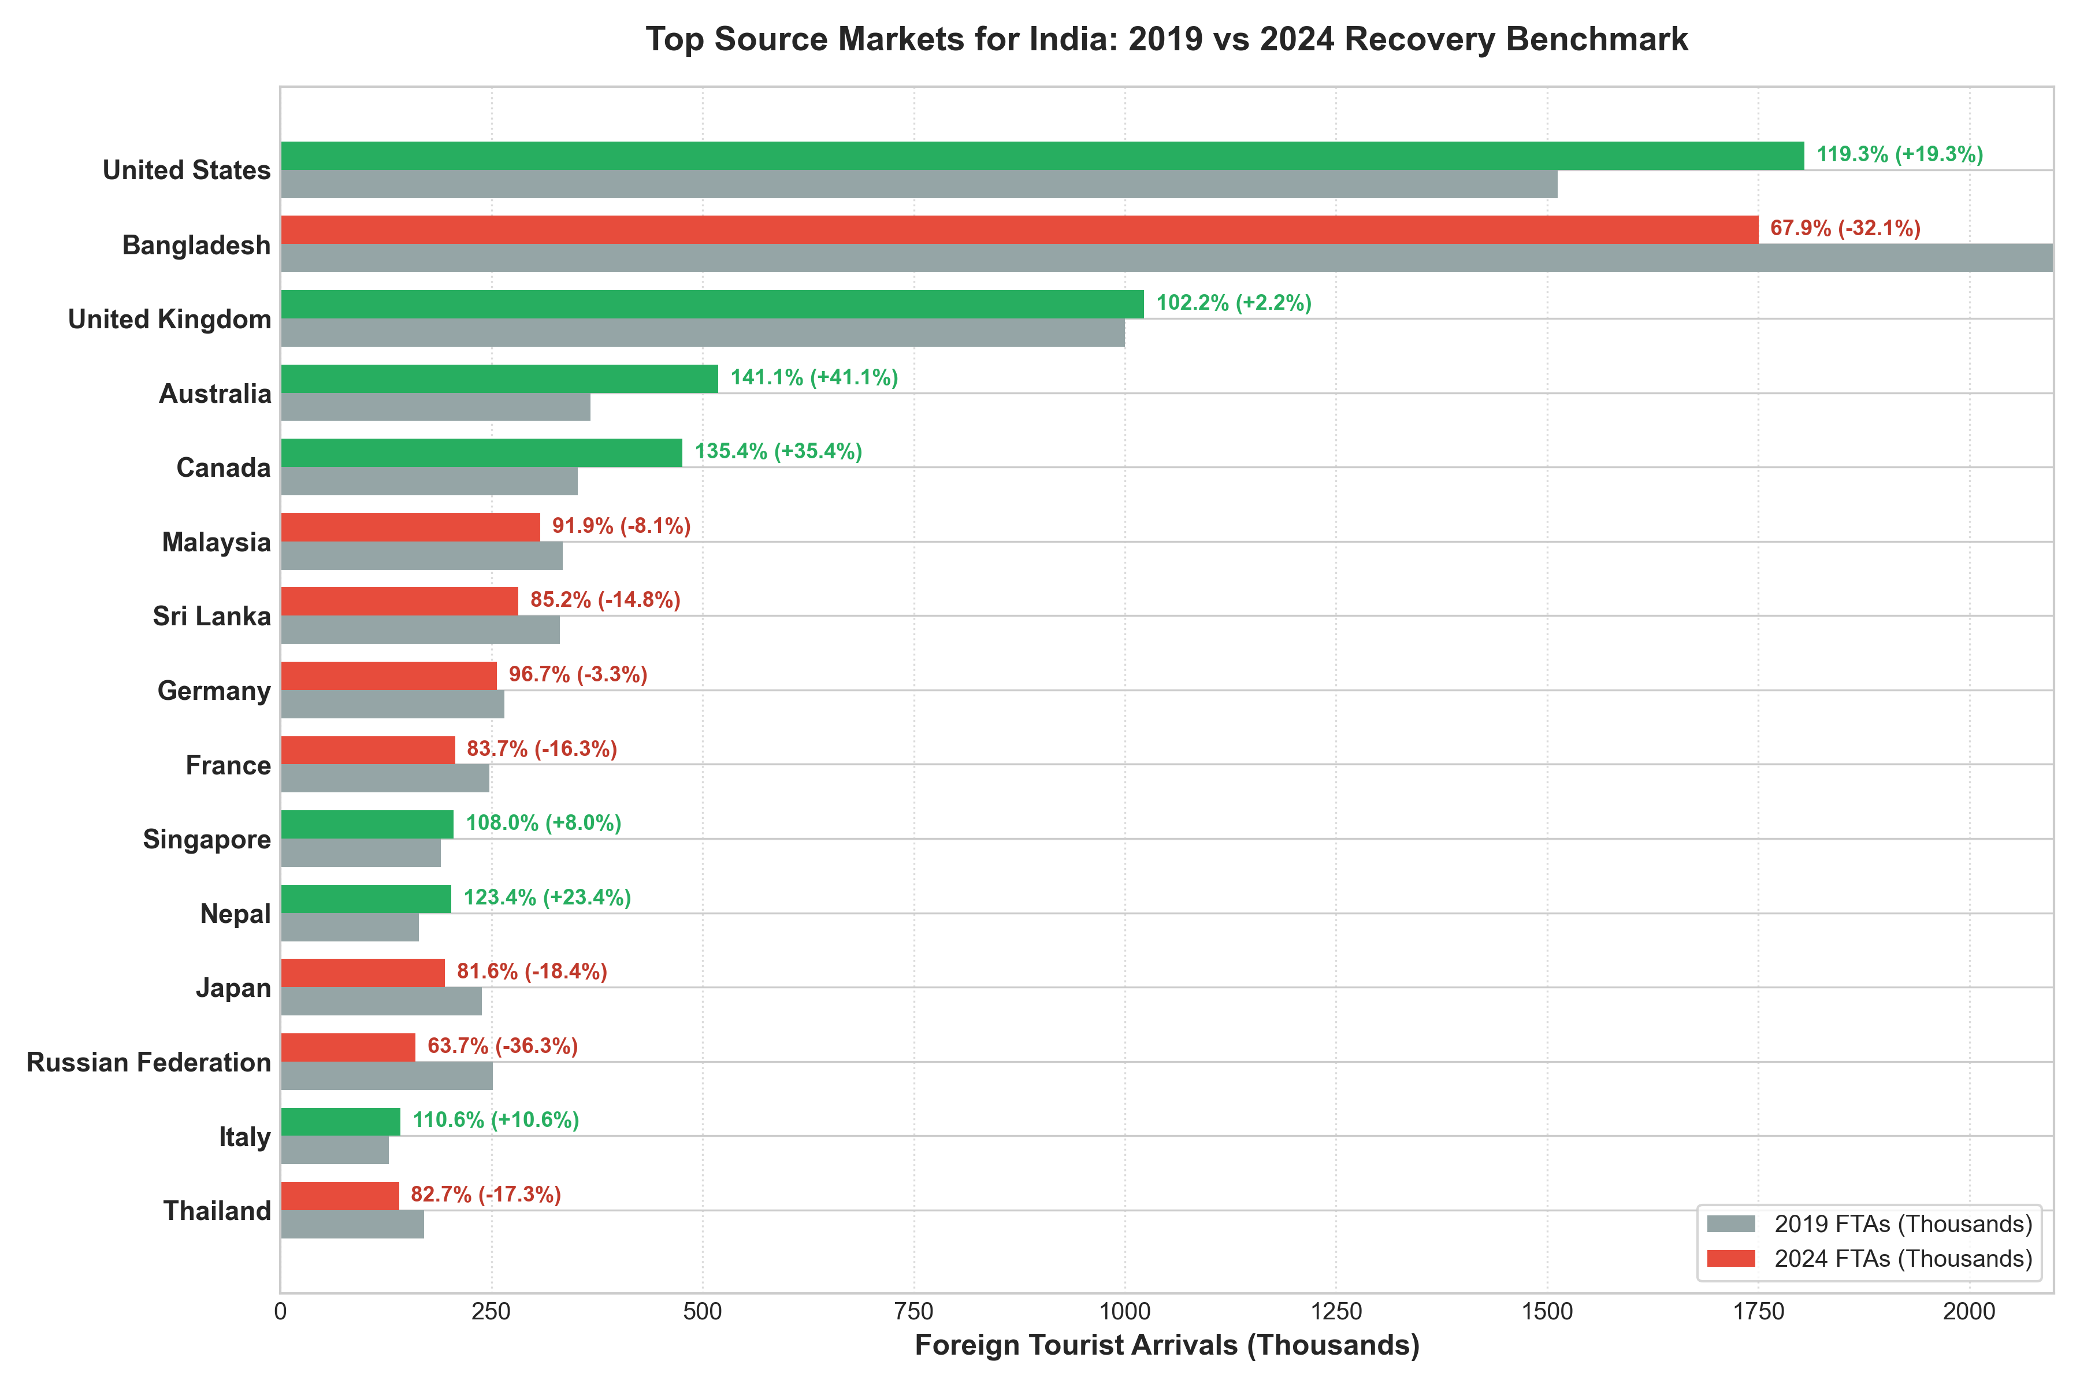
Figure 4: Benchmark Comparison of Top Source Markets: 2019 Baseline vs 2024 Actuals and Recovery Status
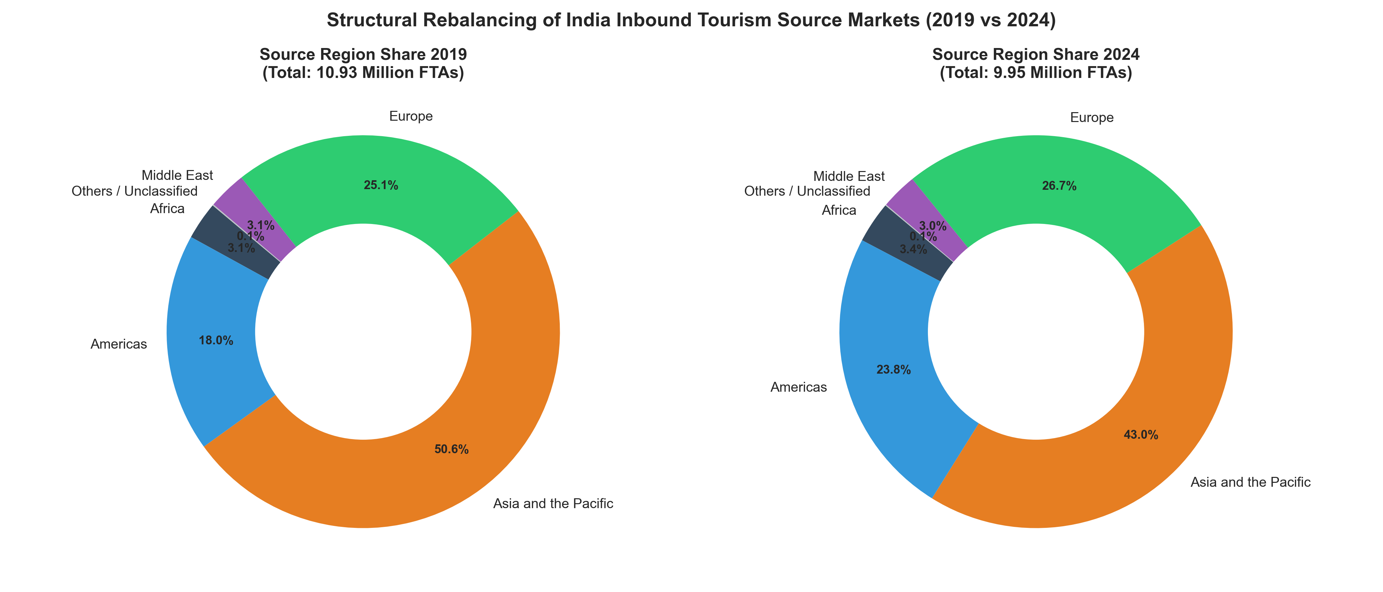
Figure 5: Structural Rebalancing of Inbound Source Regions (2019 vs 2024)
The United States is now India's #1 source market (1.80M FTAs, 18.13% share, 119.35% recovery). Bangladesh contracted by 827,562 tourists (-32.10%), explaining 84.56% of India's total national deficit. China contracted by 300,482 tourists (-88.52%), explaining 30.70%. Together, Bangladesh and China account for 115.3% of India's unrecovered tourists.

9. Temporal Granularity & Seasonality Modeling
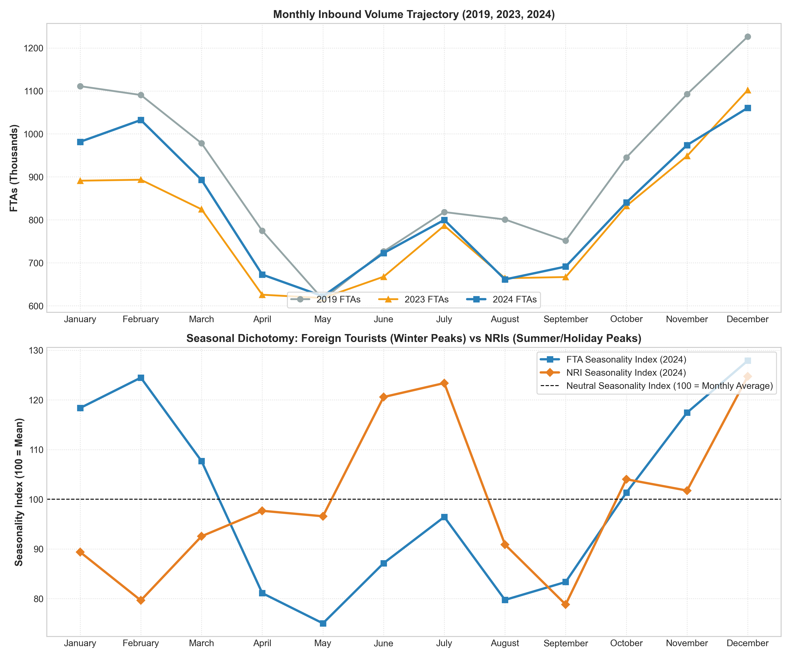
Figure 6: Temporal Seasonality Dynamics: Monthly Volume Trajectory (Top) and Seasonal Index Divergence (Bottom)
FTAs peak in December (SI = 127.9) and bottom in May (SI = 75.0), with a peak-to-lean ratio of 1.70x. NRIs peak in July (SI = 123.4) and December (SI = 124.7), providing vital counter-cyclical volume during the summer monsoon lean season.

10. Gateway Logistics & Entry Infrastructure
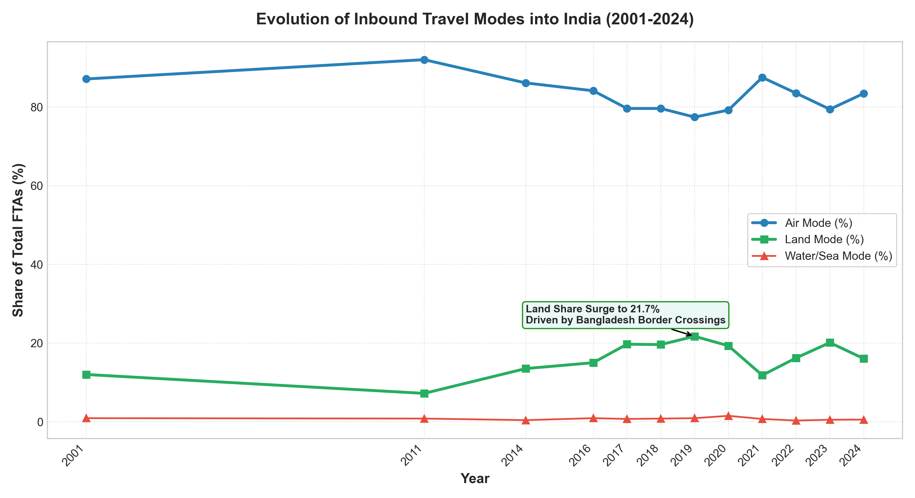
Figure 7: Long-Term Evolution of Inbound Travel Modes into India (2001–2024)
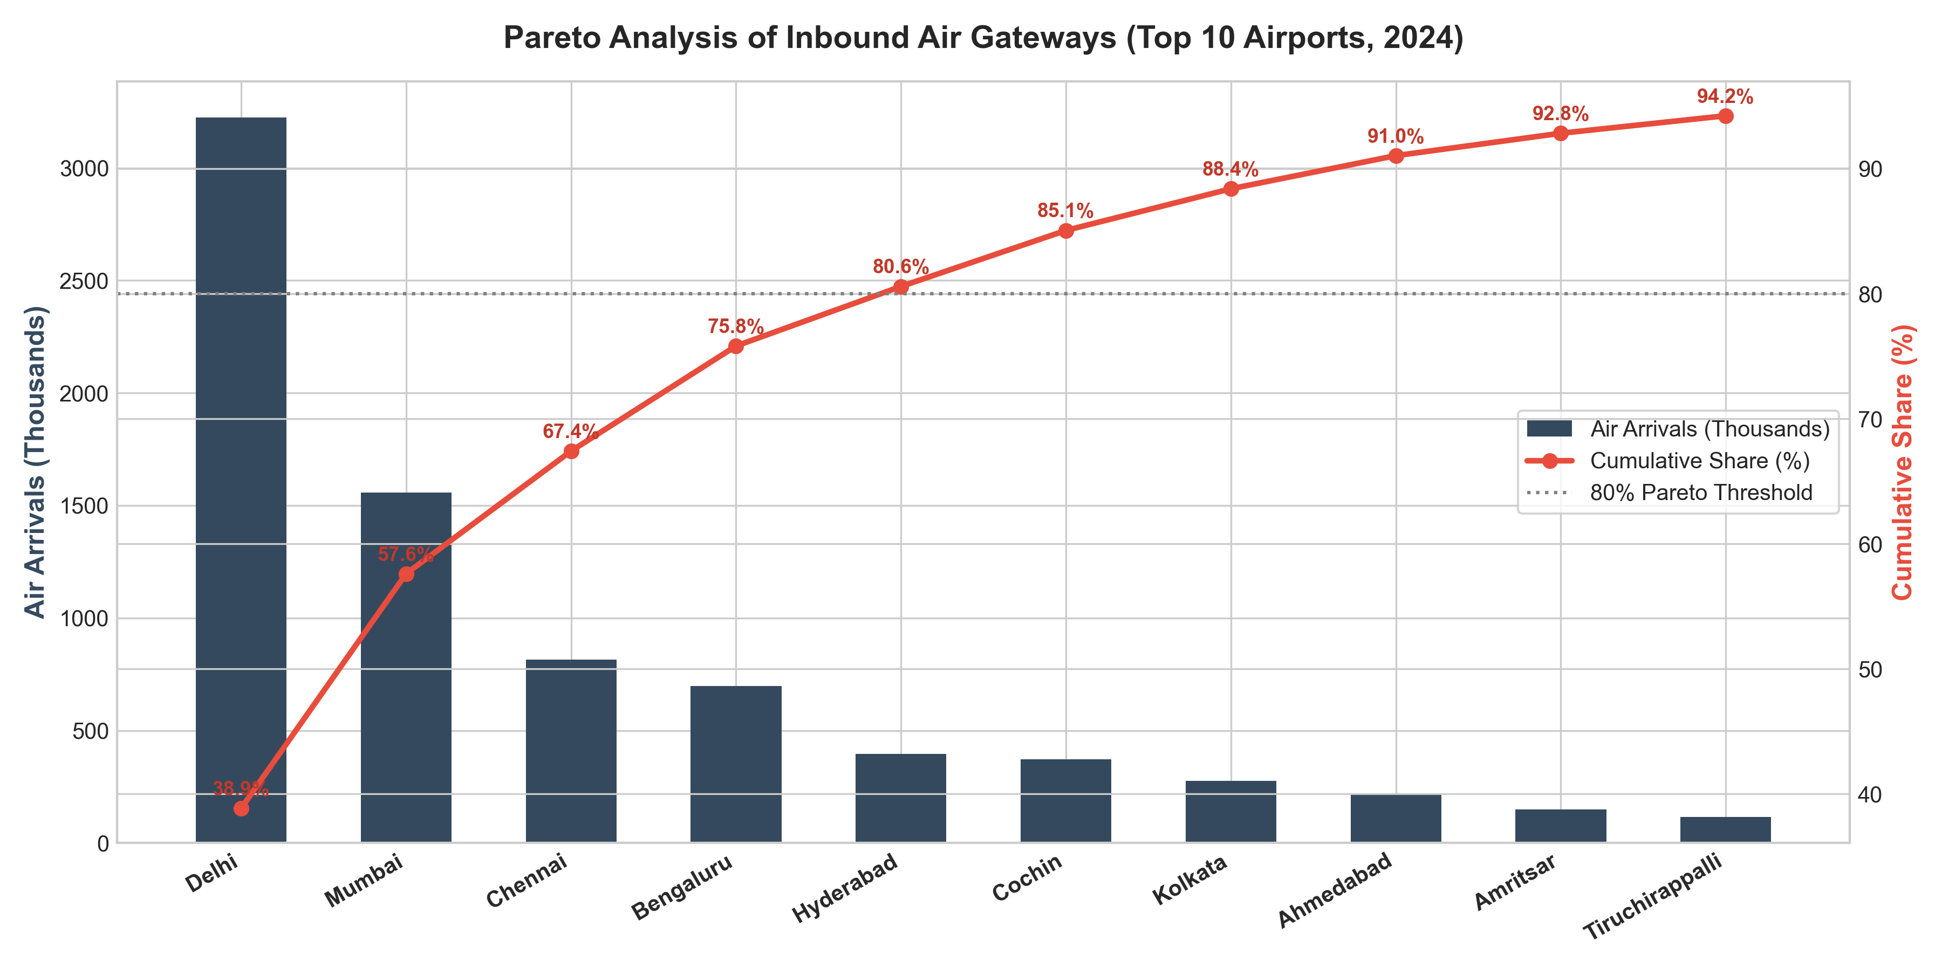
Figure 8: Pareto Analysis of International Airport Ingress (Top 10 Airports, 2024)
Air travel captured 83.41% of arrivals in 2024, while land ingress dropped to 16.05% due to reduced Bangladesh traffic. Delhi (38.85%) and Mumbai (18.76%) handle 57.61% of all air-mode arrivals, representing severe terminal concentration.

11. Potential Implications for Tourism Trends & Week 3 Roadmap
In direct fulfillment of the rubric requirement to discuss potential implications for tourism trends, we highlight four strategic takeaways:
1. Revenue Resilience Over Volume Dependence: Tourism promotion should pivot from chasing low-yielding volume to cultivating high-yielding segments. Even with 978k fewer arrivals, FEE expanded by +.3 Billion USD, proving the superior ROI of Western long-haul travelers.
2. Counter-Cyclical Asset Monetization: Hotels and airlines should leverage the NRI summer surge (June–July) with targeted family packages to offset the foreign tourist monsoon slump.
3. Gateway Decentralization: Alleviate congestion at Delhi and Mumbai by expanding direct international bilateral air rights into Tier-2 cultural destinations (Varanasi, Kochi, Goa, Amritsar).
4. Regional Land-Port Modernization: Restoring the Bangladesh corridor via streamlined e-visas and upgraded border terminals (Petrapole/Haridaspur) is the single fastest lever to recover over 800,000 lost arrivals.
Roadmap for Week 3:
• Econometric Time-Series Forecasting using SARIMA and Prophet.
• Multiple Linear Regression modeling of FEE elasticity.
• Unsupervised k-Means clustering of source nations.

